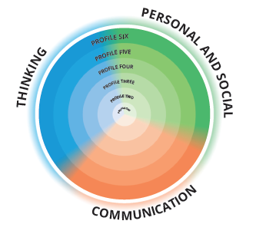
Self-Reflection and Goal Setting
The new reporting system must include student-generated content including student self-reflection of the Core Competencies and student goal setting to be added on their written report cards.
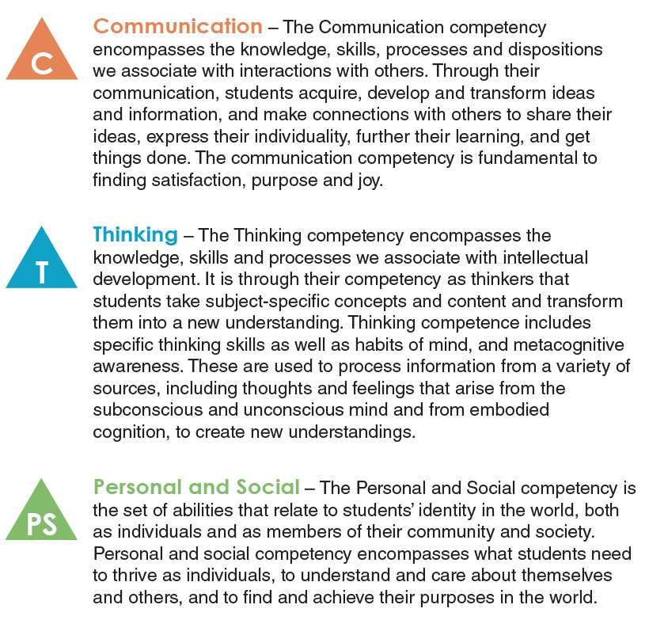
As this is a new process, especially for LEC students who may have not seen the core competency, here are the three core competencies and their definitions.

self-reflection of Core Competencies and goal setting components
- During the school year, students self-reflect and self-assess on their Core Competency development, and it is shared in the course report card.
- Every Core Competency does not need to be reflected on during a school year.
- Goal setting also does not need to be in relation to the Core Competencies.
- Self-reflection and goal setting do not need to go in the student permanent record.
- This will be individualized. Can be done as a written essay, point form, drawings, video, portfolio, etc.
- You do not need to reflect on all three core competencies.
- The core competencies are large concepts, and you can concentrate on certain aspects.
Read through the following examples of questions you can consider when writing a self-reflection or when goal setting in your course(s).
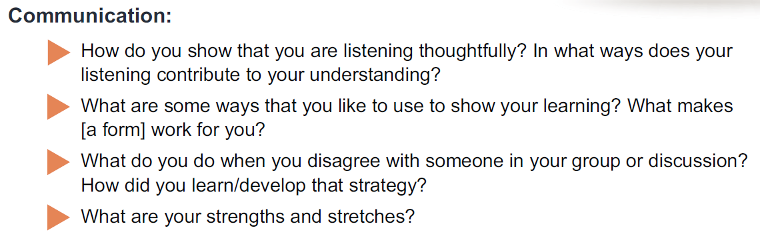
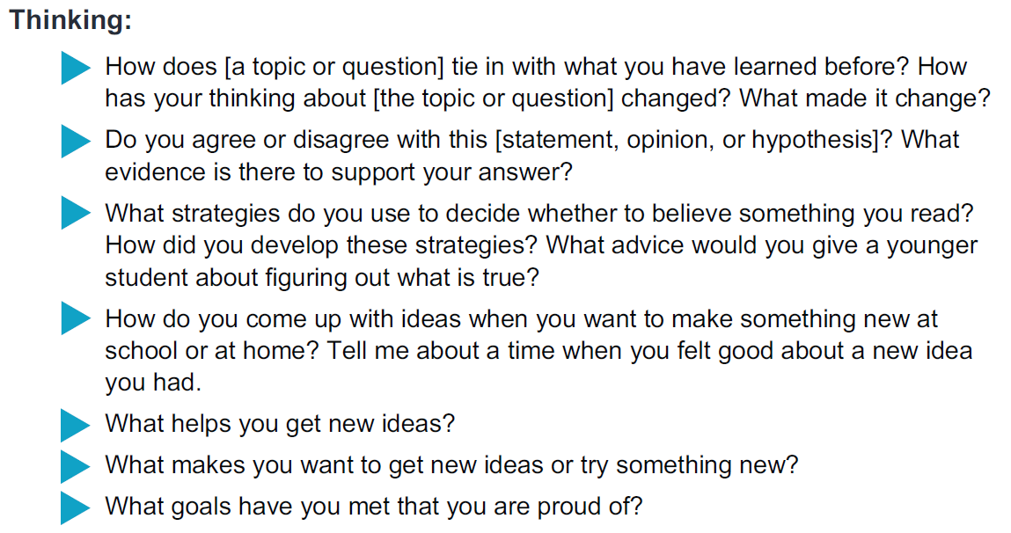
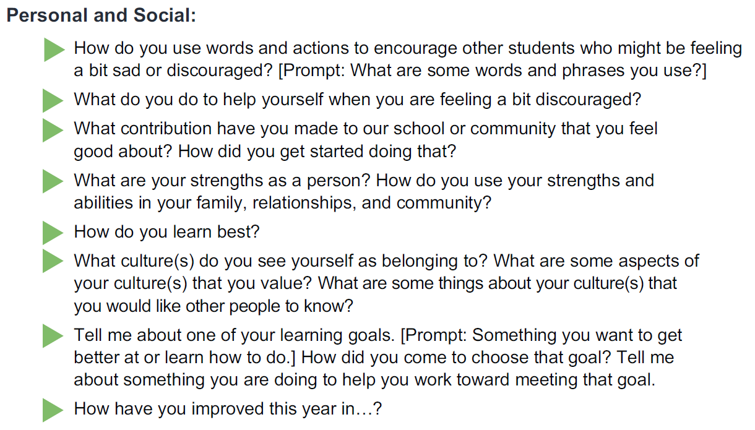
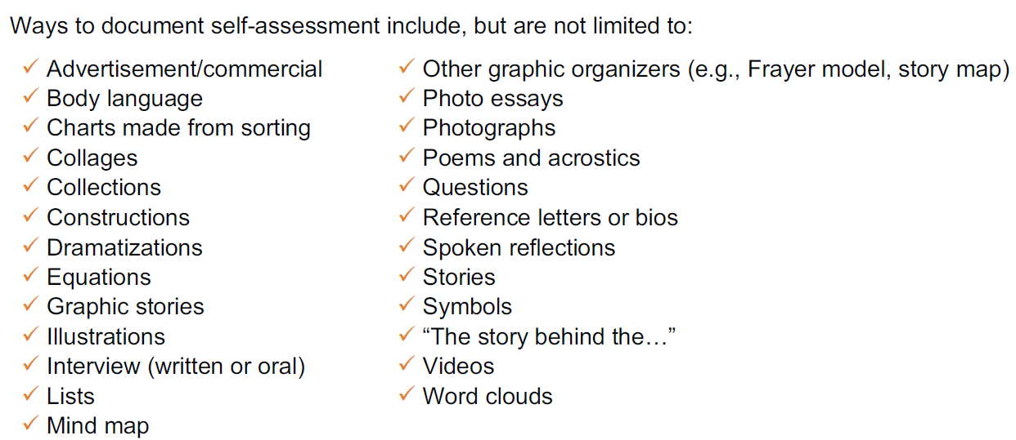
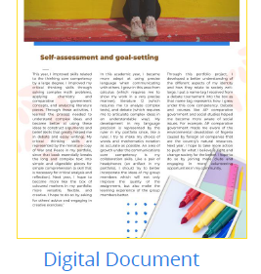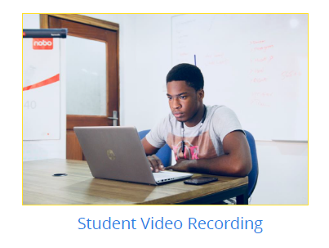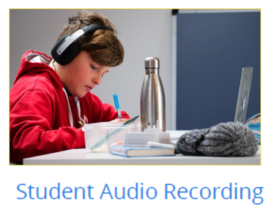

If you prefer to write/type your reflection, you can use this template for your self-reflection. Fill it in and hand back to me OR open the doc on my website, fill it in on the computer and email it to me at adhiman@sd35.bc.ca.

Start of course Reflection
Use this space to reflect on one or more of the core competencies (Communication, Thinking, Personal & Social):
FULL NAME:
DATE:
COURSE:
REFLECTION:

If you prefer to write/type your reflection, you can use this template for your self-reflection. Fill it in and hand back to me OR open the doc on my website, fill it in on the computer and email it to me at adhiman@sd35.bc.ca.

end of course Reflection
Use this space to reflect on one or more of the core competencies (Communication, Thinking, Personal & Social):
FULL NAME:
DATE:
COURSE:
REFLECTION:

